NoSQL Performance Benchmarking
Srinivasa Gorijavolu, Michael Mzyk, Satish Patharkar

Abstract— Our project team evaluated the performance of two of the most relevant NoSQL Open Source databases, Cassandra and MongoDB, in the context of a fictitious Big Data case study. Various read/write queries were used to conduct benchmarking studies in both single-node and multi-node cluster environments, and performance statistics were derived and interpreted in the context of Amdahl´s Law.

Index Terms— Amdahl´s Law, Benchmarking, Cassandra, NoSQL, Open Source, MongoDB

Introduction

This document presents the final version of our project report for the 2016 Projects on Big Data Software class. It outlines description, problem statement and purpose of the project and walks the reader through its implementation and interpretation.

Project description

As already stated in our Project proposal document, we have installed, configured and populated MongoDB and evaluated their performance under different query types (but same load conditions) in the context of the following environments:
• Single node
• multiple nodes (with n = 4)
Please note that we finally decided to leave the Spark technology out of the scope of this benchmarking study in favor of a higher level of insight regarding benchmarking results, including (but not limited to) their interpretation in the context of Amdahl´s law.

Problem statement

The startup company “Light and love” runs an online dating website designed specifically to bring together single men and women for long-term relationships. Its IT department wants to decide whether to run their noSQL databases in a standalone or in a 4-node multicluster environment, and asks our team of highly motivated IU Data Science students to elaborate and evaluate a performance benchmarking study.
This benchmarking study will be based on a sample of the most important dataset (resp. most important “asset”) of the company: its “user” dataset in JSON file format with the following characteristics:
- Around 10 mio individual user records are contained in the dataset
- Data volume is 4.2 GB (sample size)
- Data is modeled as “flat file” containing all important user records, and one record of the dataset would look like this:

{ "_id" : 56076262, "UserID" : 56076262, "UserStatus" : "Active", "UserStartDate" : "2014-02-11", "Gender" : "Male", "BirthDate" : "1959-08-25", "EducationName" : "unknown", "AssetName" : "ehc016", "CampaignDescription" : "unknown", "SegmentName" : "Default Segment", "GenderPreference" : "Female", "IncomeLevelName" : "$40000 to $60000", "UserNumberofMarriages" : 2, "UserChildren" : 3, "UserSmoke" : "2", "Promotion" : "unknown", "PPR" : "Basic PPR", "LocaleSite" : ".AU", "TransactionAmount" : 311.4, "City" : "Hillston", "ZipCode" : "2675", "State" : "New South Wales", "country" : "Australia " }

Please note that although this problem is fictitious, it is based on an (anonymized) real dataset of the online dating company “E-Harmony”.

Purpose and objectives

The purpose of this project is to gain insights on the effects of parallelization on the performance of two of the most important Open Source noSQL databases: MongoDB and Cassandra.

Main objectives of the project are:
- Get familiar with the installation and configuration of noSQL databases and, in particular, with their setup as multimode cluster environments
- Learn how to successfully write queries of different types in both MongoDB and Cassandra
- Evaluate and compare the performance of different query types based on different performance KPIs and benchmarking methods
- Interpret all obtained results in the context of Amdahl´s law

Implementation

For realizing our performance benchmarking studies on both MongoDB and Cassandra, the following high-level steps have been implemented (please note that you will find a separate document for each step in the Documents folder of our GitHub project account):

1.) Installation of MongoDB
We installed MongoDB on four nodes in the following ways:
- “manually” on a command-by-command basis
- “automatically” based on Ansible roles

2.) Configuration of MongoDB
We configured MongoDB on four nodes by following these steps:
- We created three instances of mongod processes on each node, thus creating four different “three-node-Replicasets”
- We created four MongoDB sharding cluster
- We created and enabled a shardDB database for sharding
- We imported the dataset and populated two collections called ehuser and ehuserShard.
- Please refer to the following code snippet for a summary of all four created sharding cluster:

mongos> db.ehuserShard.getShardDistribution()
...
Totals
data : 4.6GiB docs : 9053358 chunks : 43
Shard replicaSet1 contains 37.27% data, 37.27% docs in cluster, avg obj size on shard : 546B
Shard replicaSet2 contains 23.97% data, 23.97% docs in cluster, avg obj size on shard : 546B
Shard replicaSet3 contains 21% data, 21% docs in cluster, avg obj size on shard
Shard replicaSet4 contains 17.73% data, 17.73% docs in cluster, avg obj size on shard : 546B

3.) Query of MongoDB

The following queries have been executed as JavaScript files against the database (execution results will be provided in the following chapter):

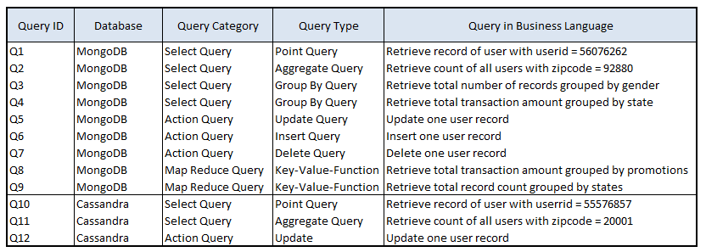
Table 1: MongoDB Query Overview

4.) Installation of Cassandra
We installed Datastax Enterprise Cassandra as both standalone and four-node environments in a manual way, i.e. on a command-to-command basis

5.) Configuration of Cassandra
We configured Cassandra on both stand-alone and multi-node cluster by following these steps:
- Connect to stand-alone resp. multi-node cluster and create key spaces

- Create table called ehuser within eh tablespace
-Create Index on ehuser table zipcode

6.) Query of Cassandra

The following queries have been executed in SQL format against the database (execution results will be provided in the following chapter):

Table 2: Cassandra Query Overview

Results

Based on general distributed and parallel computing concepts described by Hwang, K., Fox, G.C., & Dongarra, J. J. (2012), as well as performance measurement recommendations described by Li, X., & Qiu, J. (2014), we decided to focus our analysis on the following performance indicators:

- serial execution time T₁
T₁ is the execution time taken in the stand-alone cluster, also called “serial execution time”

- parallel execution time T₄
T₄ is the execution time taken in the four-node cluster, also called “parallel execution time”

- speedup S = T₁/T₄
Speedup is a derived performance indicator measuring the increase in execution speed of the four-node cluster environment as compared to the stand-alone cluster

The following benchmarking results could be obtained:
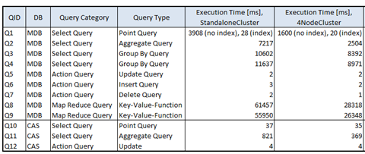

Table 3: Performance Benchmark results

Findings

1. Specific findings related to different database types

Based on Wikipedia articles for both MongoDB (cf. MongoDB (n.d.)) and Cassandra (cf. Cassandra (n.d.)) and a comparative analysis of these two databases found on Stackoverflow.com (cf. MongoDB vs. Cassandra (n.d.)), relevant findings that could be derived from our obtained results are:
- As Q1 of MongoDB shows, it is very important to think about indexes carefully for significant performance gain, while Cassandra (cf. Q10) already uses in-built indexes automatically (secondary indexes can be defined).
- However, once a MongoDB index is defined (“full index support”), a higher performance for point queries (as compared to Cassandra) can be observed.
- Regarding scalability and high performance, our results (cf. Q2 for MongoDB and Q11 for Cassandra) clearly hint at scalability and performance advantages for Cassandra when running more complex queries such as “Aggregate Queries” involving a large number of data points
- However, there are certain limitations of Cassandra as compared to MongoDB (which has more expressive query language), as certain query types such as GROUP BY Queries (cf. Q3, Q4 for MongoDB), queries using the ALL keyword or Map Reduce queries (cf. Q8, Q9 for MongoDB) are not directly supported.

2. General findings related to different query types

At first glance, there are two very obvious conclusions when looking at the “Speedup” results of all 12 queries:
- Querying and manipulating in the 4Node-Cluster environment is always faster than (or at least as fast as) in the single node collection
- However, the speedup is never equal to the total number of nodes (=4), which from a theoretical point of view would have appeared “logical” (according to the logic: 4 times more nodes → 4 times more speed)
- The Speedup S is less than N for a combination of (at least) the two reasons “load imbalance” and “communication overhead”
- At this point, it makes sense to refer to “Amdahl´s law”, which states that the relationship between speedup and number N of nodes (also called “processors”) can be modeled by the following equation:

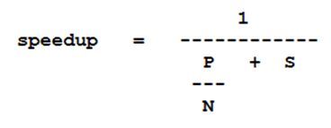
where

- P is the parallel portion of work
- S is the serial portion of work
- N is the number of cores (“processors”)

Amdahl´s Law is based on the “pessimistic” assumption that there is generally a sequential portion for a program of at least 5% of the execution time (see Figure 2), as opposed to the fact that in very large datasets the amount of sequential code can be close to 0% (however, this is clearly not our case, as we are working with a relatively small dataset, and queries with different characteristics).
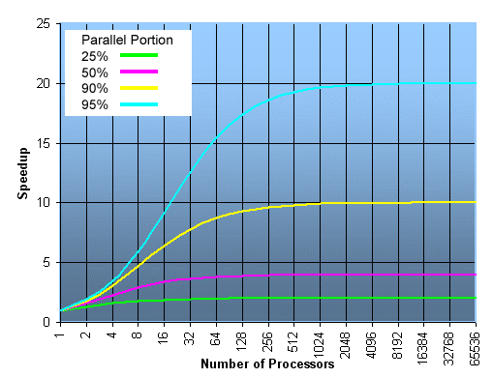
Figure 2: Number of Processors vs. Speedup in Amdahl´s Law

In order to better understand why certain query types have a higher or lower speedup value than others, we decided to estimate (!) the serial and parallel portions of work of each individual query based on the presented speedup formula of Amdahl´s Law (“backwards calculation deriving variables P and S”).

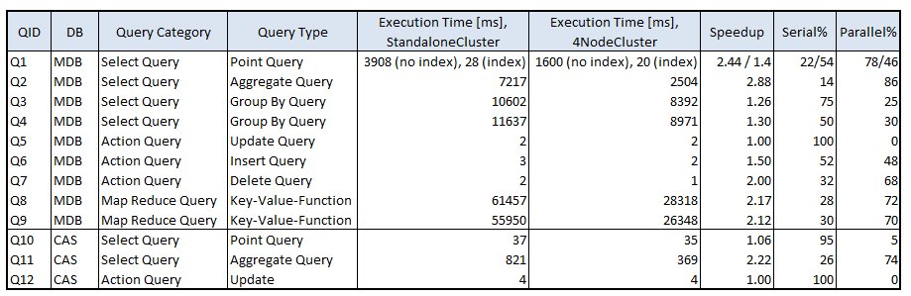
Table 4: Estimated serial and parallel portions of queries

We came to the following conclusions:
- Queries such as “Point Queries” (see Q1, Q10) or “Update/Insert/Delete Queries” (see Q5, Q6, Q7, Q12) often show lower speedup rates due to higher serial portions. We believe that this is often due to sequential “full table scans”.
- Also, complex clauses such as “Group By Queries” (which are not allowed in Cassandra; see Q3, Q4) show low speedup rates and high serial portions, once again due to “full table scans” with the GROUP BY clause “spanning” the “whole” table
- Generally, “pure” aggregate queries (such as COUNT, SUM; see Q2, Q11) and, of course, Map Reduce queries (see Q8,Q9) show higher speedup rates and lower serial portions, as they support parallel aggregation in a particular way
- MapReduce and Cassandra behave quite similar regarding most findings just mentioned, although Cassandra does not support certain types of queries (GROUP BY, ALL)

Acknowledgements

Special thanks go to our teacher Geoffrey C. Fox, Distinguished Professor of Computer Science and Informatics and Physics at Indiana University, for providing us with broad and at the same time deep knowledge in the field of Cloud Computing and Open Source Technologies, and for inspiring and motivating us to work hard on both our theoretical understanding and practical implementation skills.
We also would like to thank our advisor Hyungro Lee, Computer Science Ph.D. student at Indiana University, for his guidance and great availability to help with all project- and programming-related tasks whenever required.

References

Apache Cassandra (n.d.). In Wikipedia. Retrieved May 14, 2016, from
https://en.wikipedia.org/wiki/Apache_Cassandra
Hwang, K., Fox, G.C., & Dongarra, J. J. (2012). Distributed and Cloud Computing. Waltham, MA: Morgan Kaufmann.
Li, X., & Qiu, J. (2014). Cloud Computing for Data-Intensive Applications. New York: Springer.
MongoDB (n.d.). In Wikipedia. Retrieved May 14, 2016, from
https://en.wikipedia.org/wiki/MongoDB
MongoDB vs. Cassandra (n.d.). In Stackoverflow. Retrieved May 14, 2016, from
http://stackoverflow.com/questions/2892729/mongodb-vs-cassandra

